**КИЇВСЬКИЙ КОЛЕДЖ ЗВ´ЯЗКУ**

Циклова комісія "Комп’ютерної інженерії"

**ЗВІТ** **ВИКОНАННЯ**

**ПРАКТИЧНОГО ЗАВДАННЯ №2**

з дисципліни: «Введення до Інтернету речей»

Виконали студенти

групи РПЗ-94

Бровченко Р.А. Звєрєв В.В. ________

Перевірив викладач

Повхліб В.С. _______

Київ  2022

***Aims and objectives***

***Part 1: Testing Network Connectivity Using Ping***

***Part 2: Tracing a route to a remote server using Windows Tracert***

***Part 2: Tracing a route to a remote server using Windows Tracert***

***Part 4: Compare Traceroute results***

**Part 1. Check network connectivity with Ping**

**Звєрєв В.В.**

**Part 2. Trace a route on a remote server using Tracert**

**Бровченко Р.А.**

a) At the command line, type tracert [www.cisco.com](http://www.cisco.com).

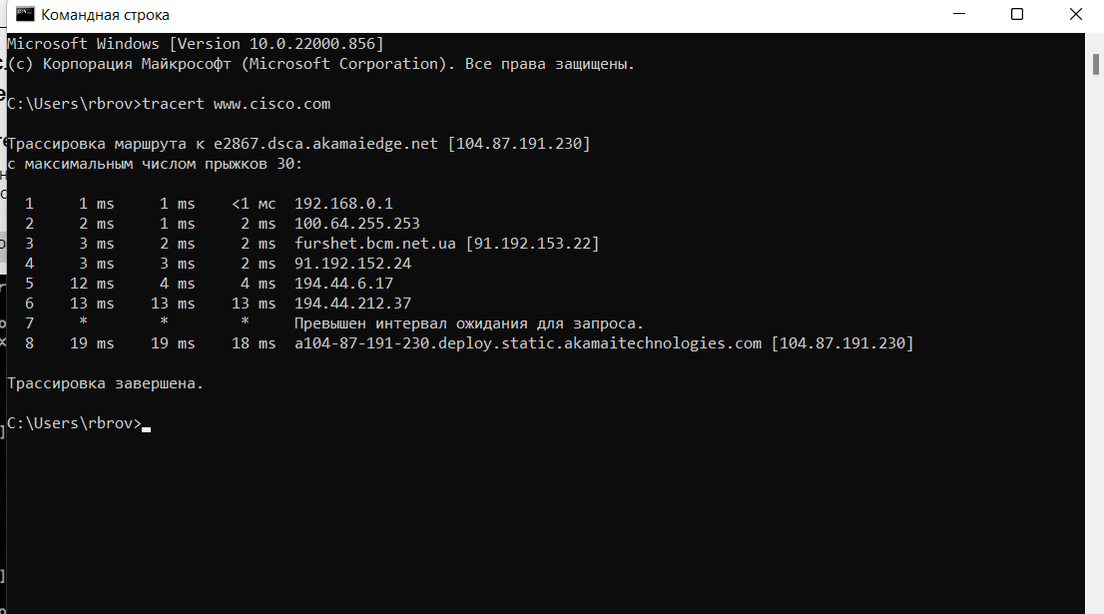

b) Save the tracert output to a text file

c) Run tracert for each destination website and save the output in sequentially numbered files.

C:\> tracert [www.afrinic.net](http://www.afrinic.net)

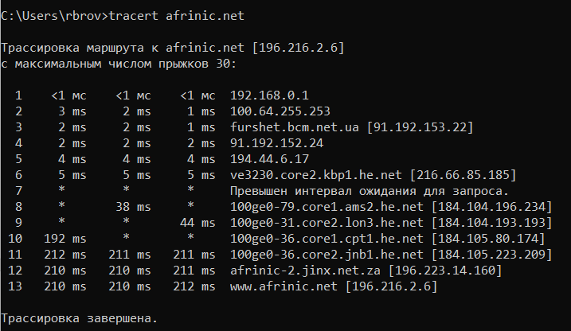

C:\> tracert [www.lacnic.net](http://www.lacnic.net)

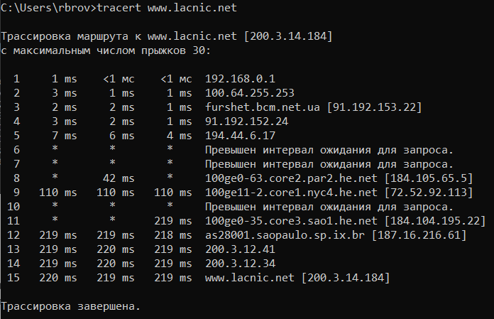

d) Interpretation of tracert results.

Streaming routes can go through multiple gateways and multiple other Internet Service Providers (ISPs) depending on the size of your ISP and the location of the source and destination hosts. Each "hop" is a router.

Because computers speak in numbers, not words, routers are uniquely identified by IP addresses (numbers with the format x.x.x.x for IPv4 addresses). The tracert tool shows the path through the network that a data packet takes to reach its final destination.

The tracert tool also provides insight into how traffic is occurring on each network segment. Three packets are sent to each router along the way, and the round trip time is measured in milliseconds. Now use this information to analyze www.cisco.com tracert results.



There is an internet tool known as Whois. The Whois tool allows you to determine who owns a domain name. The Whois web tool is located here http://whois.domaintools.com/ . This domain is also owned by Verizon according to the web Whois tool.

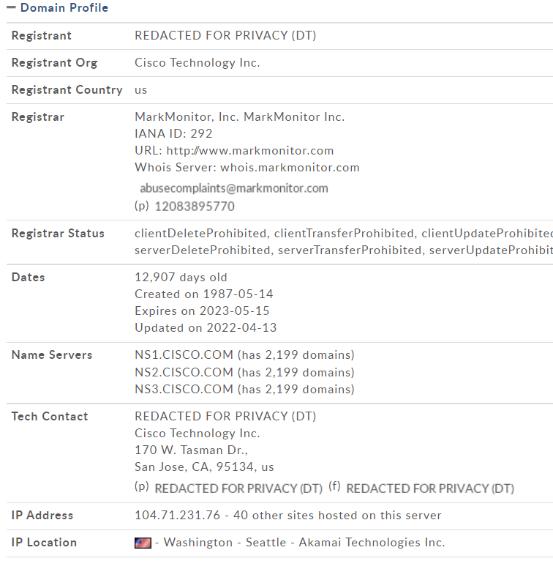

e) Now consider an example that involves Internet traffic crossing multiple ISPs Below is the tracer for www.afrinic.net :

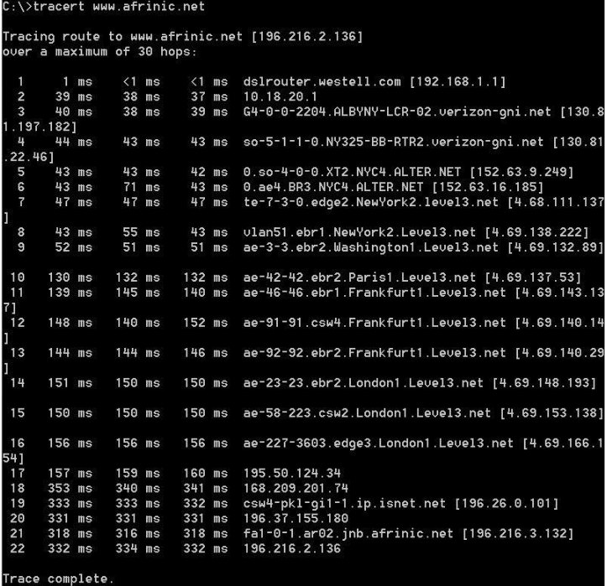

***What's happening at 7 hop? Is level3.net the same ISP as hops 2-6 or is it a different ISP? Use the Whois tool to answer this question.***

In hop 7, the IP address changes from 152.63.9.249 to 4.68.111.137 because it found a new ISP. Level 3.net is different than hops 2-6 because hops 2-6 are Verizon while hop’s 7 ISP is Level 3 Communications.

***What happens at hop 10 in the time it takes to travel a packet between Washington and Paris compared to hops 1-8?***

The time of sending packets is gradually increasing as paris is at a great distance from Washington

***What's happening at hop18? Do a Whois lookup for 168.209.201.74 using a Whois tool. Who owns this network?***

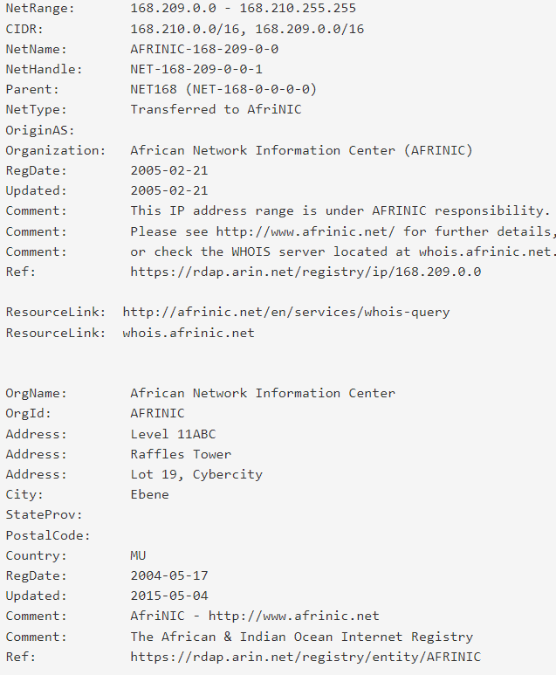

African Network Information Center owns this 168.209.201.74 network

**Part 3. Track the route on a remote server using web and software tools**

**Звєрєв В.В.**

**Part 4. Compare Traceroute results**

**Бровченко Р.А.**

Compare the traceroute results to www.cisco.com from parts 2 and 3.

Calculate the path to www.cisco.com using tracert.

Трассировка маршрута к e2867.dsca.akamaiedge.net [104.87.191.230]

с максимальным числом прыжков 30:

1 1 ms 1 ms <1 мс 192.168.0.1

2 2 ms 1 ms 2 ms 100.64.255.253

3 3 ms 2 ms 2 ms furshet.bcm.net.ua [91.192.153.22]

4 3 ms 3 ms 2 ms 91.192.152.24

5 12 ms 4 ms 4 ms 194.44.6.17

6 13 ms 13 ms 13 ms 194.44.212.37

7 * * * Превышен интервал ожидания для запроса.

8 19 ms 19 ms 18 ms a104-87-191-230.deploy.static.akamaitechnologies.com [104.87.191.230]

Трассировка завершена.

**Calculate the path to www.cisco.com using the web tool at subnetonline.com.**

TracePath Output:

1?: [LOCALHOST] pmtu 1500

1: nova.subnetonline.com 0.094ms reached

1: nova.subnetonline.com 0.042ms reached

Resume: pmtu 1500 hops 1 back 1

---- Finished ------

**List the route to www.cisco.com with VisualRoute Lite edition.**

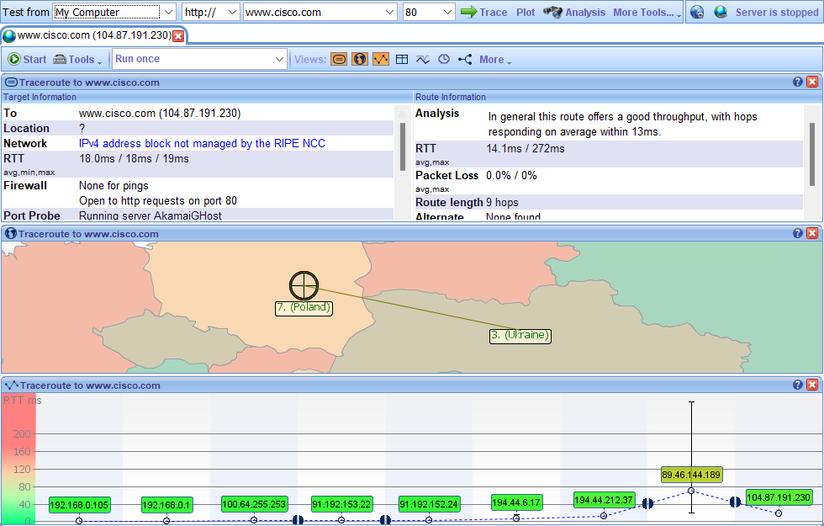

**Do all traceroutes use the same paths to www.cisco.com? Explain.**

No, because a different path will be used every time.

**Consideration**

**Having looked at traceroute with three different tools (tracert, web interface, and VisualRoute), are there any ideas that use VisualRoute provided the other two tools don't?**

Using VisualRoute is quite convenient, with this tool we can visually see how the connection to a certain network takes place, and we can also see the details of each individual hop.